

JWL-1015  JWL-1015VS | Wood Lathe
JWL-1015-M…...719100M..1~230V,50Hz
JWL-1015VS-M..719110M..1~230V,50Hz

PARTS LIST


JPW (Tool) AG
Tämperlistr. 5
CH-8117 Fällanden
Switzerland
Phone +41 44 806 47 48
Fax +41 44 806 47 58

www.jettools.com

P-719100M 2014 - 01

JWL-1015 Lathe – Exploded View

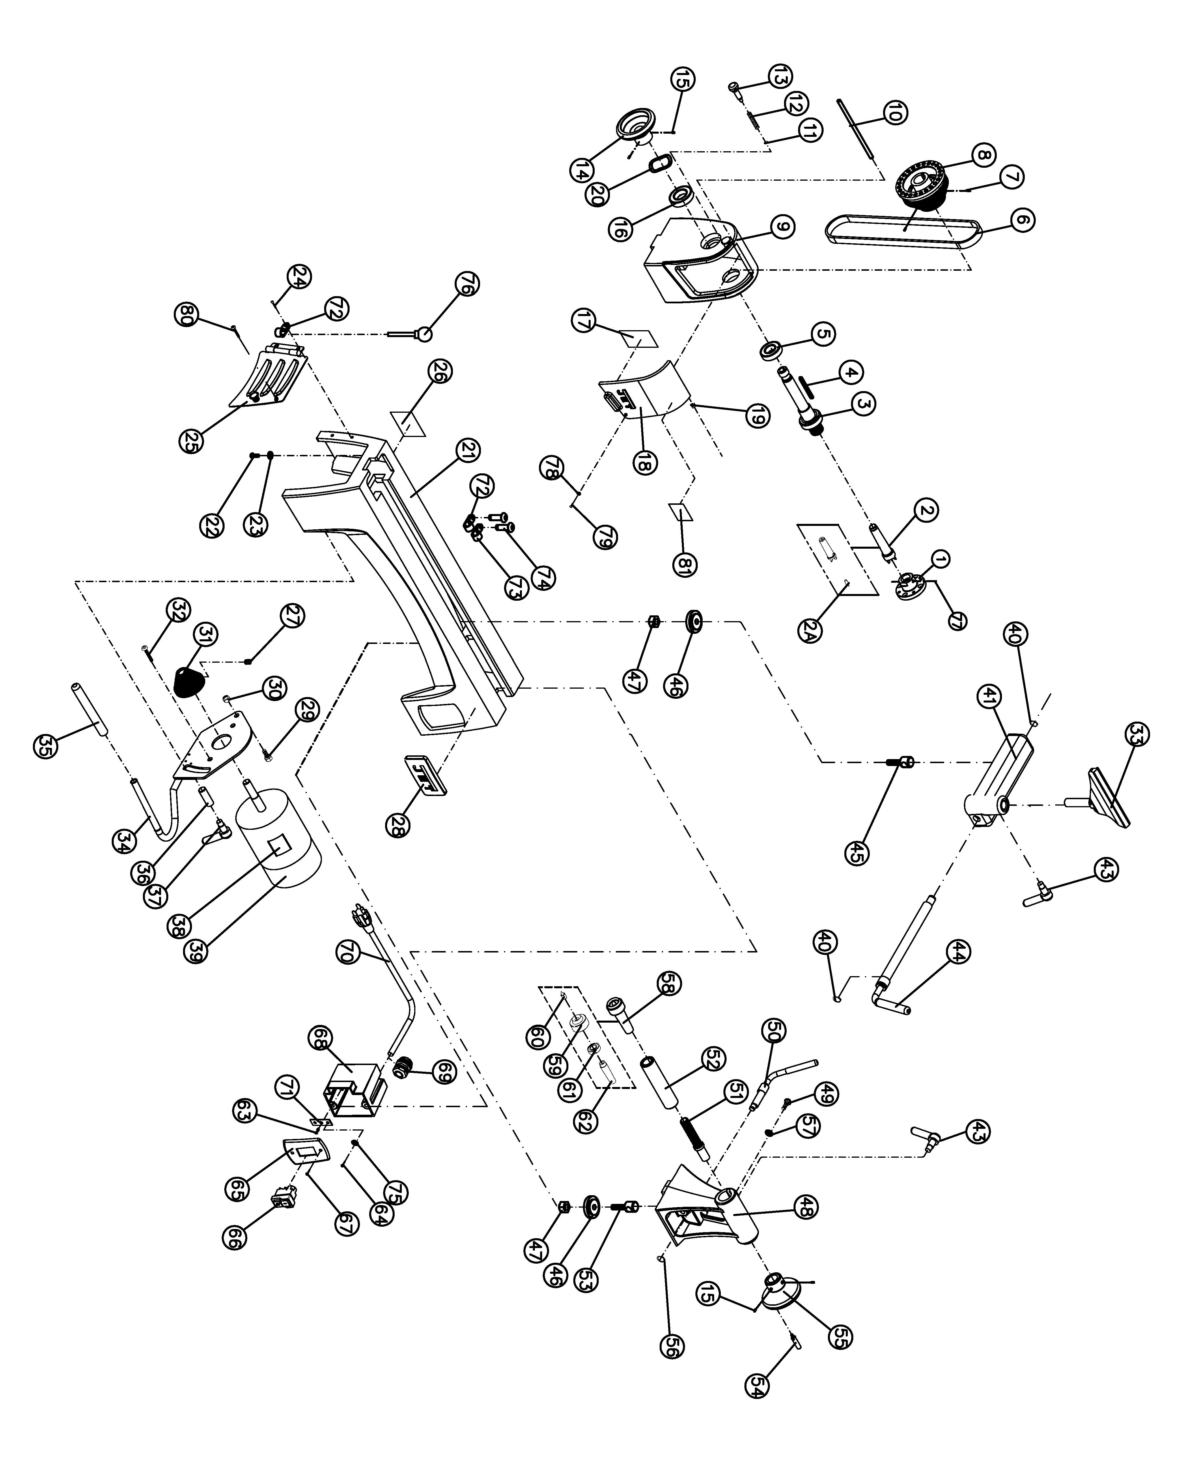
JWL-1015 Lathe – Parts List
Index No Part No Description Size Qty
JWL1015-HAE Headstock Assembly (includes #3 thru #20,#81) 1
1 6294736E Faceplate 3”, M33 1
2 JWL1642-102 Spur Center MT2 1
2A JML-3A Center Point for Spur Center 1
3 JWL1015-103E Spindle M33x3.5mm 1
4 JML-5 Key 5x25mm 1
5 BB-6005VV Ball Bearing 6005VV 1
6 JML-20 V-Belt 240J 1
7 TS-0267041 Socket Set Screw 1/4”-20x3/8” 2
8 JWL1015-108 Spindle Pulley 1
9 JWL1015-109E Headstock 1
10 JWL1015-110 Pin 1
11 JML1014-187 C-Ring STW-9 1
12 JML1014-188 Spring 1
13 JML1014-189 Index Pin 1
14 JWL1221VS-123 Handwheel 1
15 TS-0267021 Set Screw 1/4”-20x1/4” 4
16 BB-6004VV Ball Bearing 6204VV 1
17 JWL1015-117E Speed Label 1
18 JWL1015-118E Pulley Access Door 1
19 JWL1015-119 Spring 1
20 JML-8 Wave Washer 1
21 JWL1015-121E Bed 1
22 TS-0207061 Socket Head Cap Screw 1/4”-20x1” 4
23 TS-0720071 Lock Washer 1/4” 4
24 JWL1015-124 Socket Head Button Screw #10-24x1/4” 2
25 JWL1015-125E Motor Access Door 1
26 JWL1015-126E I.D Label 1
27 TS-0267041 Socket Set Screw 1/4”-20x3/8” 2
28 JET-92 JET Logo with 3M Adhesive 92x38mm 1
29 TS-0051051 Hex Cap Screw 5/16”-18x1” 1
30 TS-0640081 Nylon Lock Hex Nut 5/16”-18 1
31 JML-28 Motor Pulley 1
32 JWL1015-132 Socket Head Flat Screw 1/4”-20x1/2” 2
33 JML-42 Tool Rest 6” 1
34 JWL1015-134 Motor Bracket 1
35 JWL1221VS-266 Rubber Cover 1
36 JWL1015-136 Bushing 1
37 JWL1015-137 Lock Handle Assembly, Motor Plate 1
38 JWL1015-138E Motor Label 1
39 JWL1015-139E Motor (Included #38) 1/2HP, 1Ph, 115V 1
JML-35-1E Capacitor (not shown) 12uf,400 VAC 1
JML-35-2E Capacitor Cover (not shown) 1
JML-35-3 Motor Fan Cover (not shown) 1
JWL1015-TBA Toolrest Base Assembly (includes #40 thru #47) 2
40 JML-9 C-Ring STW-12 2
41 JWL1015-141 Tool Rest Body 1
43 JML-59A Lock Handle Assembly 5/16”-18x3/4” 2
44 JML-50 Eccentric Locking Rod 1
45 JML-43 Bolt 1
46 JML-44 Clamp 2
47 JML-81 Clamp Nut 2
JWL1015-TA Tailstock Assembly (includes #15,43,46 thru #57) 1
48 JWL1015-148 Tailstock 1
49 TS-0255031 Socket Head Button Screw 5/16”-18x5/8” 1
50 JML-58 Eccentric Rod, Tailstock 1
51 JWL1015-151 Lead Screw 1
52 JML-55 Quill 1
53 JML-64 Bolt 1
54 JWL1221VS-222 Handle 1
Index No Part No Description Size Qty
55 JWL1221VS-223 Handwheel 1
56 JML-63 C-Ring STW-10 1
57 TS-0680031 Flat Washer 5/16” 1
58 708331 Live Center Assembly (includes #59 thru #62) 1
59 JML-52 Live Center Head 1
60 JML-52A Center Point for Live Center 1
61 BB-6002ZZ Ball Bearing 6002ZZ 1
62 JML-54 Live Center Shaft 1
63 JWL1015-163 Tapping Screw M3.5x6mm 1
64 TS-1533032 Pan Head Screw M5x10 2
65 JWL1015-165E Switch Cover 1
66 JML-65E On-Off Switch 1
67 TS-081C052 Pan Head Screw #10-24x3/4” 2
68 JWL1015-168 Switch Box 1
69 JML-70E Strain Relief 2
70 JWL1015-170E Power Cord 1
71 JWL1015-171 Ground Plate 1
72 JWL1015-172 Clamp 5/16” 2
73 JWL1221VS-276 Clamp 1/2” 1
74 TS-081C022 Pan Head Screw #10-24x3/8” 2
75 TS-0733041 External Tooth Lock Washer 1/4” 2
76 JML-11 Knockout Rod 1
77 6295796 Nylon Insert Socket Set Screw 1/4-20x3/8” 2
78 JWL1221VS-136E O-Ring 1
79 TS-081C042 Screw #10-24x5/8” 1
80 TS-081C022 Pan Head Screw #10-24x3/8 1
81 JWL1221VS-137E Warning Label 1

JWL-1015VS Lathe – Exploded View
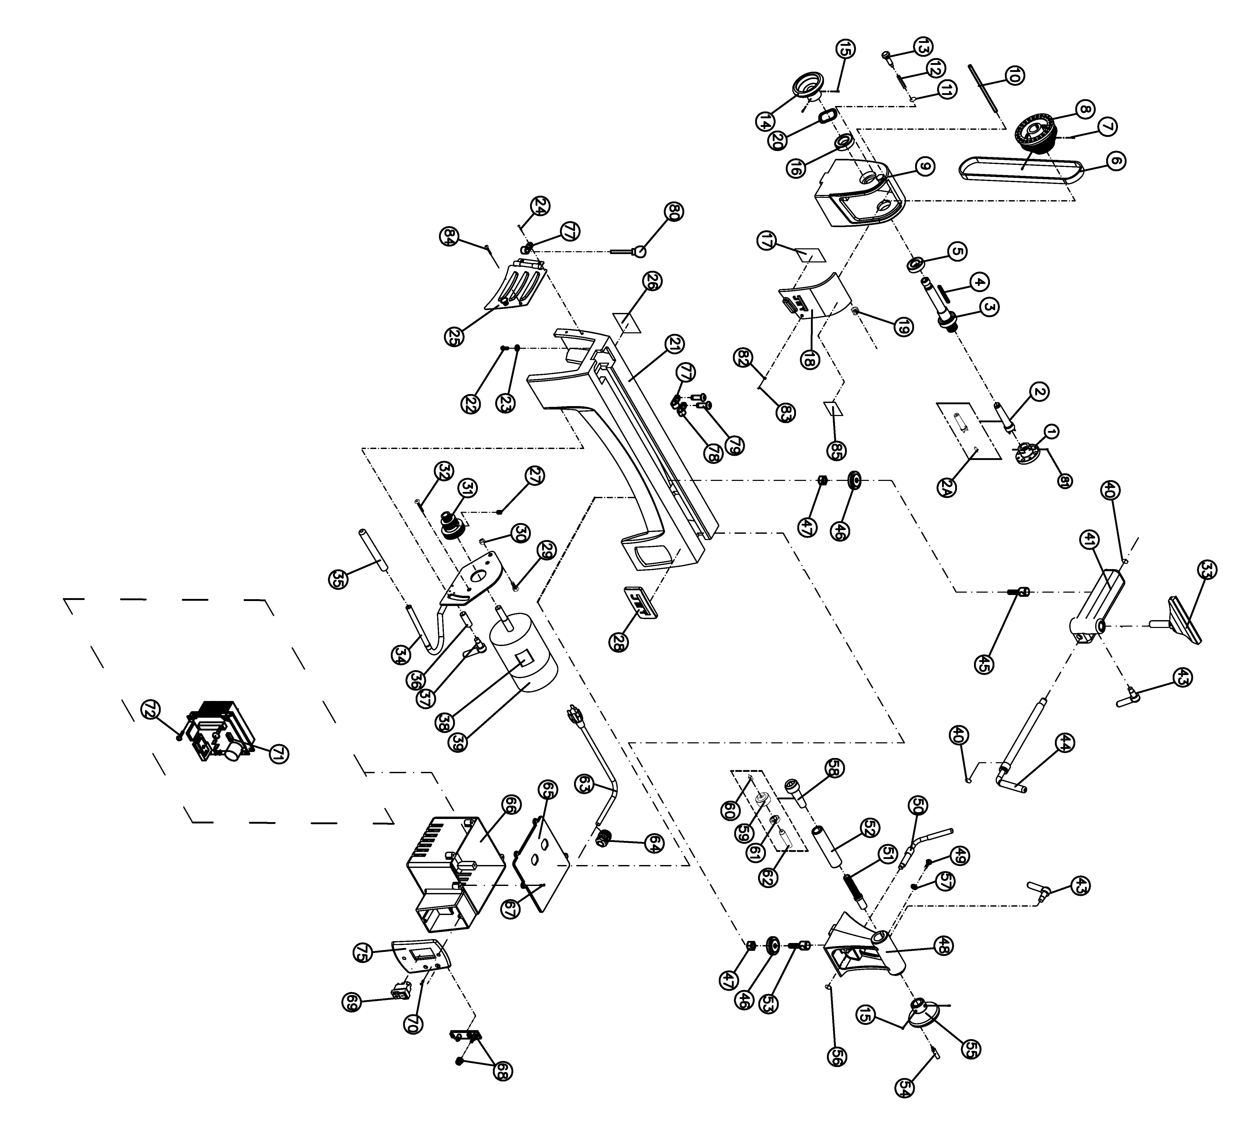

JWL-1015VS Lathe – Parts List
Index No Part No Description Size Qty
JWL1015VS-HAE Headstock Assembly (includes #3 thru #2 & #85) 1
1 JML-2 Faceplate 3” 1
2 JML-3 Spur Center MT2 1
2A JML-3A Center Point for Spur Center 1
3 JWL1015-103E Spindle M33x3.5mm 1
4 JML-5 Key 5x25mm 1
5 BB-6005VV Ball Bearing 6005VV 1
6 JML-20 V-Belt 240J 1
7 TS-0267041 Socket Set Screw 1/4”-20x3/8” 2
8 JWL1015VS-108 Spindle Pulley 1
9 JWL1015-109E Headstock 1
10 JWL1015-110 Pin 1
11 JML1014-187 C-Ring STW-9 1
12 JML1014-188 Spring 1
13 JML1014-189 Index Pin 1
14 JWL1221VS-123 Handwheel 1
15 TS-0267021 Set Screw 1/4”-20x1/4” 4
16 BB-6004VV Ball Bearing 6204VV 1
17 JWL1015VS-117E Speed Label 1
18 JWL1015-118E Pulley Access Door 1
19 JWL1015-119 Spring 1
20 JML-8 Wave Washer 1
21 JWL1015-121E Bed 1
22 TS-0207061 Socket Head Cap Screw 1/4”-20x1” 4
23 TS-0720071 Lock Washer 1/4” 4
24 JWL1015-124 Socket Head Button Screw #10-24x1/4” 2
25 JWL1015-125E Motor Access Door 1
26 JWL1015VS-126E I.D Label 1
27 TS-0267041 Socket Set Screw 1/4”-20x3/8” 2
28 JET-92 JET Logo with 3M Adhesive 92x38mm 1
29 TS-0051051 Hex Cap Screw 5/16”-18x1” 1
30 TS-0640081 Nylon Lock Hex Nut 5/16”-18 1
31 JWL1015VS-131 Motor Pulley 1
32 TS-0254021 Socket Head Button Screw 1/4”-20x1/2” 2
33 JML-42 Tool Rest 6” 1
34 JWL1015-134 Motor Bracket 1
35 JWL1221VS-266 Rubber Cover 1
36 JWL1015-136 Bushing 1
37 JWL1015-137 Lock Handle Assembly, Motor Plate 1
38 JWL1015VS-138E Motor Label 1
39 JWL1015VS-139E Motor 1/2 HP 1
JWL1015VS-MCB Motor Carbon Brush with Cap (not shown) 2
JWL1015VS-MFC Motor Fan Cover (not shown) 1
JWL1015VS-MF Motor Fan (not shown) 1
JWL1015-TBA Toolrest Base Assembly (includes #40 thru #47) 2
40 JML-9 C-Ring STW-12 2
41 JWL1015-141 Tool Rest Body 1
43 JML-59A Lock Handle Assembly 5/16”-18x3/4” 2
44 JML-50 Eccentric Locking Rod 1
45 JML-43 Bolt 1
46 JML-44 Clamp 2
47 JML-81 Clamp Nut 2
JWL1015-TA Tailstock Assembly (includes #15,43,46 thru #57) 1
48 JWL1015-148 Tailstock 1
49 TS-0255031 Socket Head Button Screw 5/16”-18x5/8” 1
50 JML-58 Eccentric Rod, Tailstock 1
51 JWL1015-151 Lead Screw 1
52 JML-55 Quill 1
53 JML-64 Bolt 1
54 JWL1221VS-222 Handle 1
Index No Part No Description Size Qty
55 JWL1221VS-223 Handwheel 1
56 JML-63 C-Ring STW-10 1
57 TS-0680031 Flat Washer 5/16” 1
58 708331 Live Center Assembly (includes #59 thru #62) 1
59 JML-52 Live Center Head 1
60 JML-52A Center Point for Live Center 1
61 BB-6002ZZ Ball Bearing 6002ZZ 1
62 JML-54 Live Center Shaft 1
JWL1015VS-CAE Controller Assembly (includes #63 thru #75) 1
63 JWL1015VS-163E Power Cord 1
64 JML-70E Strain Relief 2
65 JWL1015VS-165E Plate 1
66 JWL1015VS-166 Switch Cover 1
67 JWL1015VS-167 Tapping Screw M3x12 4
68 JWL1015VS-168E Control Potentiometer Assembly 1
69 JML-65E On-Off Switch 1
70 JWL1015VS-170 Tapping Screw 2
71 JWL1015VS-171E Circuit Board Assembly 1
72 JWL1221VS-302 Tapping Screw M3x19 4
73 JWL1015VS-174 Connect Cord (VR to PC board; not shown) 1
74 JWL1221VS-324 Connect Cord (Power cord to PC board; not shown) 1
75 JWL1015VS-175E Switch Cover 1
77 JWL1015-172 Clamp 5/16” 2
78 JWL1221VS-276 Clamp 1/2” 1
79 TS-081C022 Pan Head Screw #10-24x3/8” 2
80 JML-11 Knockout Rod
81 6295796 Nylon Insert Socket Set Screw 1/4-20x3/8” 2
82 JWL1221VS-136E O-Ring 1
83 TS-081C042 Screw #10-24x5/8” 1
84 TS-081C022 Pan Head Screw #10-24x3/8 1
85 JWL1221VS-137E Warning Label 1

JWL-1015-M…..719100M….1~230V,50Hz

 | colour of strands | Litzenfarben | couleur des cordons
BK | black | schwarz | noir
WH | white | weiß | blanc
BU | blue | blau | bleu
YE | yellow | gelb | jaune
RD | red | rot | rouge
BN | brown | braun | brun
GY | grey | grau | gris
GNYE | green-yellow | grün-gelb | vert-jaune
OG | orange | orange | orange
VT | violet | violett | violet

 | meaning of symbol | Bedeutung der Zeichen | interprétation
M | motor | Motor | moteur
S | switch | Schalter | interrupteur
C | condenser | Kondensator | condensateur
E | electronic unit | Elektronik Einheit | unité électronique
F | fuse | Sicherung | fusible
RS | reversing switch | Drehrichtungsschalter | commu. droite/gauche
CS | centrifugal switch | Fliehkraftschalter | déclencheur centrifuge
OL | overload cut-off | Überlastschutzschalter | déclencheur surcharge
LS | limit switch | Positionsendschalter | micro

JWL-1015VS-M..719110M….1~230V,50Hz

 | colour of strands | Litzenfarben | couleur des cordons
BK | black | schwarz | noir
WH | white | weiß | blanc
BU | blue | blau | bleu
YE | yellow | gelb | jaune
RD | red | rot | rouge
BN | brown | braun | brun
GY | grey | grau | gris
GNYE | green-yellow | grün-gelb | vert-jaune
OG | orange | orange | orange
VT | violet | violett | violet

 | meaning of symbol | Bedeutung der Zeichen | interprétation
M | motor | Motor | moteur
S | switch | Schalter | interrupteur
C | condenser | Kondensator | condensateur
E | electronic unit | Elektronik Einheit | unité électronique
F | fuse | Sicherung | fusible
RS | reversing switch | Drehrichtungsschalter | commu. droite/gauche
CS | centrifugal switch | Fliehkraftschalter | déclencheur centrifuge
OL | overload cut-off | Überlastschutzschalter | déclencheur surcharge
LS | limit switch | Positionsendschalter | micro

